OpenADR 3.1 / IEC 62746-4 Mapping
— Semantic Analysis

Contents
- Purpose 2
- Standards in Scope 2
  - IEC 62746-4 — Demand Side Resource Interface 2
2.2. IEC 62325-351 — ESMP 3
2.3. OpenADR 3.1 3
- Summary Mapping Assessment 3
- Strengths of the Mapping 5
  - Structural Convergence at the Interval Layer 5
  - Dual Encoding Support 5
  - Actor Model and Stacked Aggregation 5
  - Dispatch Lifecycle 6
  - ReferenceEnergyCurve Schema Unification 6
  - Transport Modernisation 6
- Weaknesses and Semantic Gaps 6
  - Document Identity: mRID Scoping 6
  - Market Participant Identity and Role 7
  - Monotonic Revision Control 7
  - Per-Instruction Binding Flag 7
  - Missing Payload Types for Upward Flexibility 7
  - Separation of Energy and Price in Flex Offers 8
  - Unit Code Scale Risk 8
  - Identifier Namespace Loss 8
  - XSD Schema Differentiation Not Yet Implemented 9
- Conclusions 9
Appendix A: Gap Register 9
Appendix B: References and Specification Links 10
  - OpenADR 3.1 Specification 10
  - IEC Standards Referenced 11
Appendix C: UML Diagram Index 11
Appendix D: UML Diagrams 11
  - Actor Mapping 12
  - IEC 62746-4 Information Model 13
  - OpenADR 3.1 Core Model 14
  - Field Mapping 15

  - ScheduleKind Mapping 16
  - Standards Hierarchy 17
Appendix E: OpenADR 3.1 Reference Images 18
  - OpenADR 3.1 Data Model 18
  - OpenADR 3.1 Transition Diagram 19

Purpose
This document provides a semantic analysis of the OpenADR 3 Program Description: IEC CIM Alignment Profile (draft, April 3, 2026), which maps OpenADR 3.1 constructs to IEC 62746-4 (Demand Side Resource Interface) and the IEC European Style Market Profile (IEC 62325-351, ESMP). The analysis evaluates the strength of the mapping — what the profile achieves well and where genuine semantic gaps remain unresolved or are only partially bridged by naming convention.

Six PlantUML diagrams accompany this report in the uml/ folder:

File | Content
01_actor_mapping.puml | IEC 62746-4 actor hierarchy ↔ OpenADR 3.1 actor model
02_iec62746_informatio n_model.puml | IEC 62746-4 / ESMP message types and their shared structure
03_openADR_core_model. puml | OpenADR 3.1 core data model — profile-relevant subset
04_field_mapping.puml | Field-level mapping with gap annotations
05_schedule_kind_mappi ng.puml | IEC ScheduleKind → OpenADR payloadType cross-reference
06_standards_hierarchy  .puml | CIM → ESMP → IEC 62746-4 / OpenADR 3.1 standards lineage

Standards in Scope

IEC 62746-4 — Demand Side Resource Interface
IEC 62746-4 is an IEC TC57 WG21 standard that defines the information model and message schemas for demand-side resource management at the DSO-aggregator and aggregator-customer interfaces. It derives from the Common Information Model (CIM) via the European Style Market Profile (IEC 62325-351, ESMP), inheriting ESMP document identification, ENTSOE code lists, and the two-convention time series encoding framework (explicit 62746-4-1 and implicit 62746-4-2).
The message types addressed in the profile are:

    - ReferenceEnergyCurveOperatingEnvelope — Dynamic Operating Envelopes (DOE)
    - ReferenceEnergyCurveBaselineNotification — baseline and actuals reporting
    - ReferenceEnergyCurveFlexOffer — flexibility volume and price offers

    - MarketDERInstruction — real-time and day-ahead DER dispatch
    - CommodityPriceExchange — price signals (separate companion document)
    - MarketDER — DER registration (TBD in profile)

2.2. IEC 62325-351 — ESMP
The ESMP is the European regional CIM profile governing wholesale market operations. Its document header pattern — mRID, revisionNumber, Sender/Receiver_MarketParticipant, Process.processType, Period.timeInterval — is inherited by all IEC 62746-4 messages. The ESMP also defines the ENTSOE code lists (unit codes, quality codes, market role codes) and the two time series encoding conventions.

2.3. OpenADR 3.1
OpenADR 3.1 is a lightweight REST/JSON/MQTT demand-response standard providing a program / event / report / interval / payload data model with OAuth2 authentication and publish-subscribe webhook notifications. OpenADR 3.1 is designed as a transport-and-API layer; it defines no CIM UML profile and carries no ESMP document header conventions.

Summary Mapping Assessment
The table below consolidates the mapping quality across the four main use cases. Ratings are: Strong (direct structural equivalence), Functional (equivalent behaviour via different mechanism), Convention (requires agreed naming or encoding convention, not standardised), and Gap (no equivalent — extension or standardisation required).

IEC 62746-4 Concept | Mapping Quality | Summary
Core interval/time series structure | Strong | OpenADR’s intervalPeriod + interval.id + payload.values maps directly to ESMP Series_Period + Point.position + Quantity.
Implicit vs. explicit encoding (4- 2 vs. 4-1) | Strong | OpenADR natively supports both: event-level intervalPeriod (implicit) and per-interval intervalPeriod (explicit).
Actor hierarchy (SPS / AEMS / CEMS) | Strong | BL / VEN-aggregator / VEN-resource maps cleanly, including the stacked aggregator pattern.
FlowDirection and ScheduleKind | Strong (4 of 6 values) | Four ScheduleKind values map to standard OpenADR payload types; two require private extensions.
Lifecycle commands (ACTIVATE  / ADJUSTMENT / RELEASE) | Strong | OpenADR CRUD operations (POST / PUT / DELETE) provide direct operational equivalence.

IEC 62746-4 Concept | Mapping Quality | Summary
createdDateTime /  modificationDateTime | Strong | Direct ISO 8601 UTC equivalents.
mRID (document identity) | Convention | IEC mRID is originator-assigned and globally unique; event.id is VTN-scoped. Cross-system traceability requires embedding IEC mRID in event.eventName by convention.
revisionNumber | Functional | event.modificationDateTime captures version- identification purpose but is not a monotonic integer counter. Strict revision tracking requires convention.
Sender/Receiver market roles | Convention | Party identity via OAuth2 bearer token; MarketRole (e.g. A46 DSO, A04 aggregator) has no OpenADR equivalent — implied by program context.
Resource identifier namespace (codingScheme) | Convention | RESOURCE_NAME is an opaque string; ENTSOE EIC/GS1 namespace metadata of IEC RegisteredResource.mRID is lost.
Unit code translation (ENTSOE  → OpenADR) | Convention | KWT→KW, MAW→MW, MWH→KWH. Scale  conversion risk on the MWH→KWH step.
Quality code translation (ENTSOE → DATA_QUALITY) | Convention | A01→MISSING, A02→ESTIMATED, A03→OK,  A04→BAD. Convention table, not standardised.
bindingInstruction per instruction | Gap | OpenADR only supports bindingEvents at program level; per-instruction binding requires a proposed payloadDescriptor.obligatory extension (not yet standardised).
EXPORT_USAGE (export baseline) | Gap | No standard OpenADR payload type for export- direction baseline. Private extension x- USAGE_EXPORT required.
loadIncrease / generationReduction ScheduleKind | Gap | No standard payload types for upward load regulation or generation curtailment. Private extensions x-LOAD_INCREASE_DELTA_AVAIL and x- GENERATION_REDUCTION_DELTA_AVAIL required.
Order_MarketDocument back- reference | Gap | No OpenADR equivalent for back-reference to originating market order. Workaround: embed in eventName convention.
Process.processType  (DAM/RTM/HAM) | Convention | Market session type encoded in  program.programName by convention only.
PriceDescriptor.marketType /  priceType | Gap | No OpenADR equivalent for price market type or price type categorisation.

IEC 62746-4 Concept | Mapping Quality | Summary
FlexOffer + Price as separate updatable objects | Functional  (with loss) | The profile combines ReferenceEnergyCurveFlexOffer + CommodityPriceExchange into a single Report interval. Energy and price cannot be updated independently, which has market-audit significance at TSO-BSP level.
MarketDER DER registration | Gap | Registration attributes (isAggregatedRes, market service certifications, registration status) have no OpenADR equivalent. TBD in profile.
Domain.mRID (control zone) | Functional | Mapped to targets {SERVICE_AREA|GROUP} — closest OpenADR enumeration for geographic/grid zones.
XSD schema differentiation (4-1 vs. 4-2) | Gap (IEC side) | Explicit and Implicit XSD file pairs are currently identical at schema level. Profile conventions anticipate schema differentiation by WG21.

Strengths of the Mapping

Structural Convergence at the Interval Layer
The deepest and most consequential strength is the structural convergence between the IEC Series_Period / Point layer and the OpenADR intervalPeriod / interval / payload layer. Both model the same concept — a sequenced series of timestamped values — using structurally equivalent constructs. The mapping Point.position → interval.id, Point.Quantity → payload.values[0], and Series_Period.resolution → intervalPeriod.duration is direct and lossless.
This convergence is not accidental: OpenADR 3.1 was designed to carry demand-response time series data, which is the primary content of IEC 62746-4 messages. The profile correctly exploits this structural alignment as its load-bearing foundation.

Dual Encoding Support
OpenADR 3.1 natively supports both IEC time series encoding conventions without modification to either standard. Event-level intervalPeriod (shared start and resolution, intervals indexed by id) mirrors IEC 62746-4-2 implicit encoding. Per-interval intervalPeriod (each interval carries its own start and duration) mirrors IEC 62746-4-1 explicit encoding. This symmetry is a genuine architectural alignment, not a workaround.

Actor Model and Stacked Aggregation
The IEC actor hierarchy — SPS / AEMS / CEMS — maps cleanly onto OpenADR’s BL / VEN-aggregator
/ VEN-resource pattern. The most sophisticated element is the stacked aggregator: IEC 62746-4

requires the AEMS to act simultaneously as a resource toward the SPS and as an operator toward CEMSs. OpenADR 3.1’s design, where a VEN in one program can act as BL/VTN in a nested program, natively supports this pattern without profile-specific extensions.

Dispatch Lifecycle
The mapping of IEC instructionType (ACTIVATE / ADJUSTMENT / RELEASE) to OpenADR CRUD operations (POST / PUT / DELETE) is architecturally elegant and semantically tight. The VEN receives the correct notification type for each operation via the standard OpenADR webhook mechanism, with no additional signalling required.

ReferenceEnergyCurve Schema Unification
The fact that all four ReferenceEnergyCurve message types share a single underlying schema structure is a significant simplification. A single OpenADR interval pattern with appropriately named payload types (IMPORT_CAPACITY_LIMIT, EXPORT_CAPACITY_LIMIT, USAGE, LOAD_SHED_DELTA_AVAILABLE, GENERATION_DELTA_AVAILABLE) covers all four variants. This is the strongest argument in the profile’s IEC submission case: OpenADR 3.1 is not a loose approximation of IEC 62746-4 — it covers the full ReferenceEnergyCurve family with a single, clean encoding pattern.

Transport Modernisation
IEC 62746-4 defines the information model but not the transport mechanism. OpenADR 3.1 fills this gap with REST/JSON/MQTT and OAuth2 — a modern, widely implemented stack. The profile’s approach of expressing IEC 62746-4 message content inside OpenADR 3.1 structures provides the best of both: IEC semantic rigour with OpenADR’s lightweight, cloud-native transport. This is architecturally superior to the adapter/XSLT pattern used in the predecessor (IEC 62746-10-3 for OpenADR 2.0b).

Weaknesses and Semantic Gaps

Document Identity: mRID Scoping
The most consequential semantic gap is the mRID scoping model. IEC mRID is originator-assigned, globally unique, and immutable across all systems — it is the authoritative cross-system document identifier used for settlement, auditing, and message correlation. OpenADR event.id is VTN- assigned and scoped to the VTN — it has no meaning outside the VTN that created it.
The profile’s workaround — embedding the IEC mRID in event.eventName by convention — is pragmatically workable but semantically fragile. eventName is an informational string with no enforced uniqueness constraints in OpenADR 3.1. Any system that reads the event relies on an undocumented convention rather than a structured field. For regulatory environments where cross-system document traceability is required (DSO settlement, flexibility market auditing), this gap is significant.

Proposed mitigation: Define a program.customAttributes or event.customAttributes mechanism in OpenADR 3.x that provides a structured key-value extension point, allowing IEC mRID to be carried as a typed, queryable field rather than a naming convention.

Market Participant Identity and Role
IEC 62746-4 carries sender and receiver party identity — including MarketRole codes (e.g. A46 = grid operator, A04 = DSO, A07 = aggregator) — explicitly in every message body. This is a deliberate ESMP design: each message is self-describing with respect to the parties and roles involved, enabling audit trail reconstruction without external context.
OpenADR delegates party identity entirely to OAuth2 bearer token authentication. MarketRole has no equivalent field in any OpenADR object. The profile notes this is "implicit from the program context," but program context is not a message field — it is external configuration.
For DSO-aggregator interfaces subject to regulatory oversight (e.g. European flexibility market frameworks under SOGL Article 182), the absence of explicit market role tagging is a material gap.

Monotonic Revision Control
IEC revisionNumber is a mandatory monotonic integer counter that uniquely identifies each version of a document. It enables receivers to detect out-of-order delivery, duplicate processing, and version conflicts — critical properties in the high-availability environments where grid management systems operate.
OpenADR’s modificationDateTime provides temporal ordering but is not a monotonic counter. Two updates with identical timestamps (possible in fast-paced dispatch scenarios) cannot be distinguished by modificationDateTime alone. The profile acknowledges this gap and suggests a BL convention in eventName, but this is not an adequate substitute for a structured, machine- processable monotonic identifier.

Per-Instruction Binding Flag
IEC MarketDERInstruction.Instructions.bindingInstruction (YES / NO) distinguishes mandatory compliance from advisory guidance per instruction. This granularity is important for dispatch scenarios where some setpoints are firm grid-stability requirements and others are market- advisory.
OpenADR 3.1 only provides program.bindingEvents — a program-level boolean that applies uniformly to all events in the program. The profile proposes a payloadDescriptor.obligatory extension, but this has not been standardised. Until it is, operators must maintain separate programs for binding and non-binding instructions, increasing program proliferation and management overhead.

Missing Payload Types for Upward Flexibility
The two ScheduleKind values loadIncrease and generationReduction — representing upward load

regulation and generation curtailment respectively — have no standard OpenADR 3.1 payload type equivalents. These are not edge cases: upward load regulation (demand increase for absorbing excess renewable generation) is a key flexibility service in markets with high renewable penetration. The profile requires private extensions (x-LOAD_INCREASE_DELTA_AVAIL, x- GENERATION_REDUCTION_DELTA_AVAIL), which by definition cannot be interoperably exchanged without bilateral agreement.
Similarly, export-direction baseline notifications require a private x-USAGE_EXPORT extension because OpenADR’s USAGE payload type has no direction qualifier.

These three missing payload types represent the most actionable technical gap for standardisation and should be prioritised in the next OpenADR 3.x revision (tracked as Action for Frank Sandoval in the draft).

Separation of Energy and Price in Flex Offers
IEC deliberately separates ReferenceEnergyCurveFlexOffer (energy volume) and CommodityPriceExchange (price) as independent market objects. This separation allows either the volume or the price to be revised independently — for example, a resource may update its price offer in the intraday market without resubmitting its full energy curve.

The profile combines both into a single OpenADR Report interval. While this simplifies the DSO- aggregator interface, it sacrifices the independent update semantics that IEC designed for regulatory and audit reasons. A VEN that wishes to update only its price must resubmit the full Report including unchanged energy values, potentially triggering unintended processing on the BL side.
For interfaces where the energy curve and price are under the control of different organisational units within the aggregator (a common real-world configuration), this coupling is a practical concern.

Unit Code Scale Risk
The profile requires translating IEC ENTSOE unit code MWH (megawatt-hour) to OpenADR’s KWH (kilowatt-hour) with corresponding numerical scaling. For power units, KWT → KW is scale-neutral. For energy units, MWH → KWH requires multiplying values by 1000.

This silent numerical transformation is a source of implementation error. The profile recommends using KWH consistently but does not specify where the scaling is applied (BL vs. VTN vs. VEN). In a multi-party integration (DSO, aggregator, CIM-based metering system), any party that reads IEC values and writes OpenADR values must apply the scale factor — but there is no field-level indicator in the OpenADR message that the values have been scaled.

Identifier Namespace Loss
IEC resource identifiers carry a codingScheme attribute (e.g. A01 = ENTSOE EIC, A10 = GS1) that identifies the identifier namespace. OpenADR RESOURCE_NAME is an opaque string with no namespace metadata.

For grid domains where multiple identifier schemes coexist (e.g. an aggregator managing resources identified by EIC in the TSO domain and by GS1 in a metering domain), the loss of namespace context makes automated identifier resolution impossible without out-of-band configuration.

XSD Schema Differentiation Not Yet Implemented
The Explicit (IEC 62746-4-1) and Implicit (IEC 62746-4-2) XSD schemas are currently identical. The encoding convention distinction exists in the WG21 directory structure but not at the schema level. The profile correctly implements both encoding conventions in its JSON examples, but conformance testing against the normative schemas is not yet possible. This is a gap on the IEC side that must be resolved before the profile can be submitted as a normative IEC publication.

Conclusions
The profile is technically sound and demonstrates genuine architectural convergence between IEC 62746-4 and OpenADR 3.1. The load-bearing claim — that the OpenADR interval/payload model is structurally equivalent to the IEC Series_Period / Point model — is correct and well-evidenced. The dual-encoding, stacked-aggregator, and CRUD-lifecycle mappings are strong.
The mapping’s weaknesses cluster in two areas. The first is ESMP documentary infrastructure: mRID global uniqueness, revisionNumber monotonic revision control, and explicit MarketRole tagging are deep ESMP conventions that OpenADR never attempted to replicate, and for which naming- convention workarounds are fragile in regulated market environments. The second is payload type completeness: three missing standard payload types (upward load, generation curtailment, export baseline) require private extensions that reduce interoperability precisely in the use cases — high- renewable-penetration demand flexibility — where this profile matters most.
Both clusters are resolvable: the first through a structured extension mechanism in OpenADR (typed custom attributes), the second through three new payload type enumerations in OpenADR
3.x. The profile’s open items section (Section 9) correctly identifies these action items and assigns ownership. Resolving them before formal IEC TC57 submission would materially strengthen the conformance claim.

Appendix A: Gap Register

ID | Gap Description | Profile Workaround | Severity
G-01 | mRID VTN-scoped vs. globally unique | Embed in event.eventName by convention | High
G-02 | No monotonic revisionNumber | modificationDateTime + naming convention | Medium
G-03 | MarketRole not in message body | Implicit from OAuth2 + program context | Medium
G-04 | Resource codingScheme / identifier namespace lost | Agreed naming convention on  RESOURCE_NAME string | Medium

ID | Gap Description | Profile Workaround | Severity
G-05 | bindingInstruction per- instruction vs. per-program | Separate programs per binding level | Medium
G-06 | No EXPORT_USAGE payload type | Private x-USAGE_EXPORT  extension | High
G-07 | No  LOAD_INCREASE_DELTA_AVAILABLE  payload type | Private x- LOAD_INCREASE_DELTA_AVAIL  extension | High
G-08 | No  GENERATION_REDUCTION_DELTA_AVA  ILABLE payload type | Private x- GENERATION_REDUCTION_DELTA_AVA  IL extension | High
G-09 | FlexOffer energy and price cannot be updated independently | Full Report resubmission required | Low–Medium
G-10 | Order_MarketDocument back- reference has no equivalent | Naming convention in  eventName | Low
G-11 | Process.processType / marketType  / priceType not mapped | Naming convention in  programName | Low
G-12 | MWH→KWH unit scale transformation is implicit | Profile recommendation; no field-level indicator | Medium
G-13 | XSD schemas for 4-1 and 4-2 are currently identical | (IEC-side gap) JSON examples provide differentiation | Medium
G-14 | MarketDER registration attributes have no equivalent | TBD in profile | Medium

Appendix B: References and Specification Links

OpenADR 3.1 Specification

Resource | Link
OpenADR 3.1.0 Specification (GitHub) | https://github.com/grid-coordination/openadr3- specification/tree/main/3.1.0
OpenADR 3.1 OpenAPI Schema | https://github.com/grid-coordination/openadr3- specification/blob/main/3.1.0/openapi.yaml
OpenADR Alliance (official) | https://www.openadr.org

IEC Standards Referenced

Standard | Description
IEC 62746-4 | Demand Side Resource Interface — information model and message schemas for DSO-aggregator and aggregator- customer interfaces
IEC 62746-10-1 (IEC/PAS) | OpenADR 2.0b as IEC specification — predecessor to this profile
IEC 62325-351 (ESMP) | European Style Market Profile — CIM regional profile governing ESMP document header conventions, ENTSOE code lists, and time series encoding
IEC 62325-451-7 | Balancing market business processes (TSO–BSP) — architecturally upstream of OpenADR 3.1 scope
IEC CIM | Common Information Model — abstract UML ontology from which all above standards derive

Appendix C: UML Diagram Index

Diagram | Description
uml/01_actor_mapping.p uml | IEC 62746-4 actor hierarchy ↔ OpenADR 3.1 actor model, with gap annotations on party identity and resource namespace
uml/02_iec62746_inform ation_model.puml | IEC 62746-4 / ESMP message types — shared AbstractDocument header, ReferenceEnergyCurve family, MarketDERInstruction, CommodityPriceExchange, MarketDER
uml/03_openADR_core_mo del.puml | OpenADR 3.1 core data model (program / event / interval / payload / report / resource / ven) with profile payload type enumeration
uml/04_field_mapping.p uml | Field-by-field mapping table rendered as a UML dependency diagram, annotated with mapping quality (direct / convention / gap)
uml/05_schedule_kind_m apping.puml | Complete IEC ScheduleKind → OpenADR payloadType cross-reference across all message contexts, highlighting the two private extension gaps
uml/06_standards_hiera rchy.puml | CIM → ESMP → IEC 62325-451-x and IEC 62746-4 → OpenADR 3.1  standards lineage, showing scope boundary of this profile

Appendix D: UML Diagrams

Actor Mapping
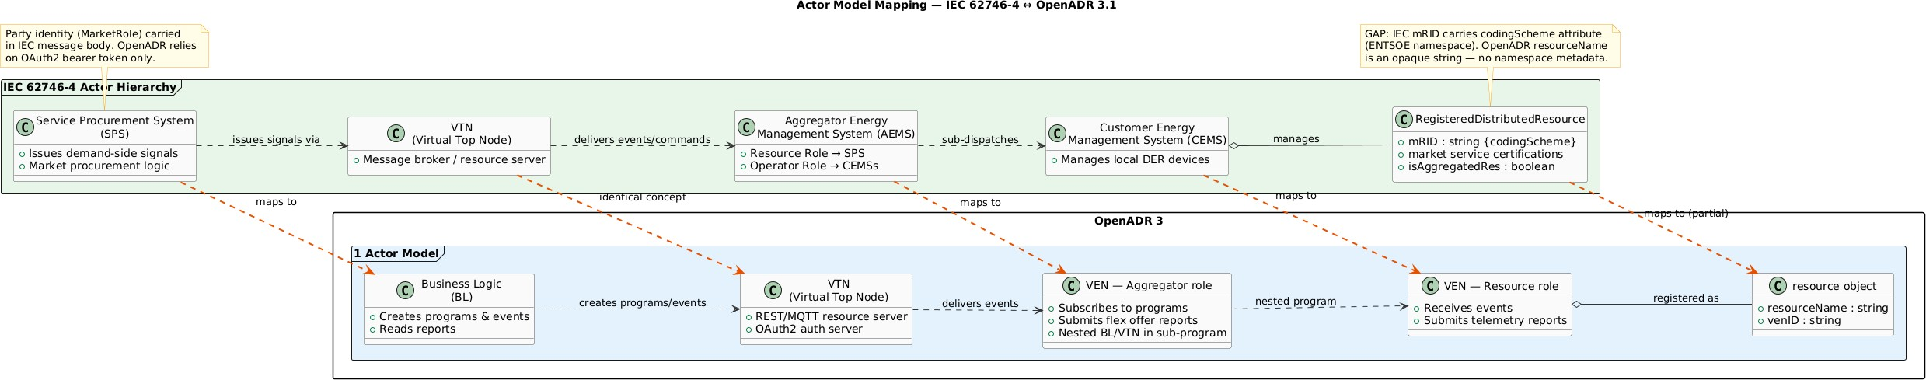

IEC 62746-4 Information Model
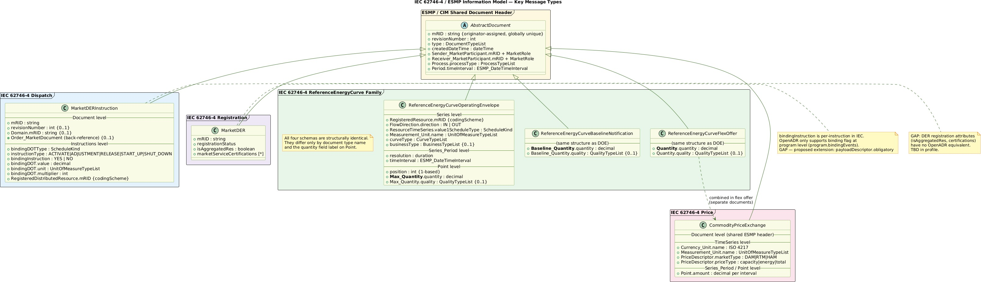

13

OpenADR 3.1 Core Model
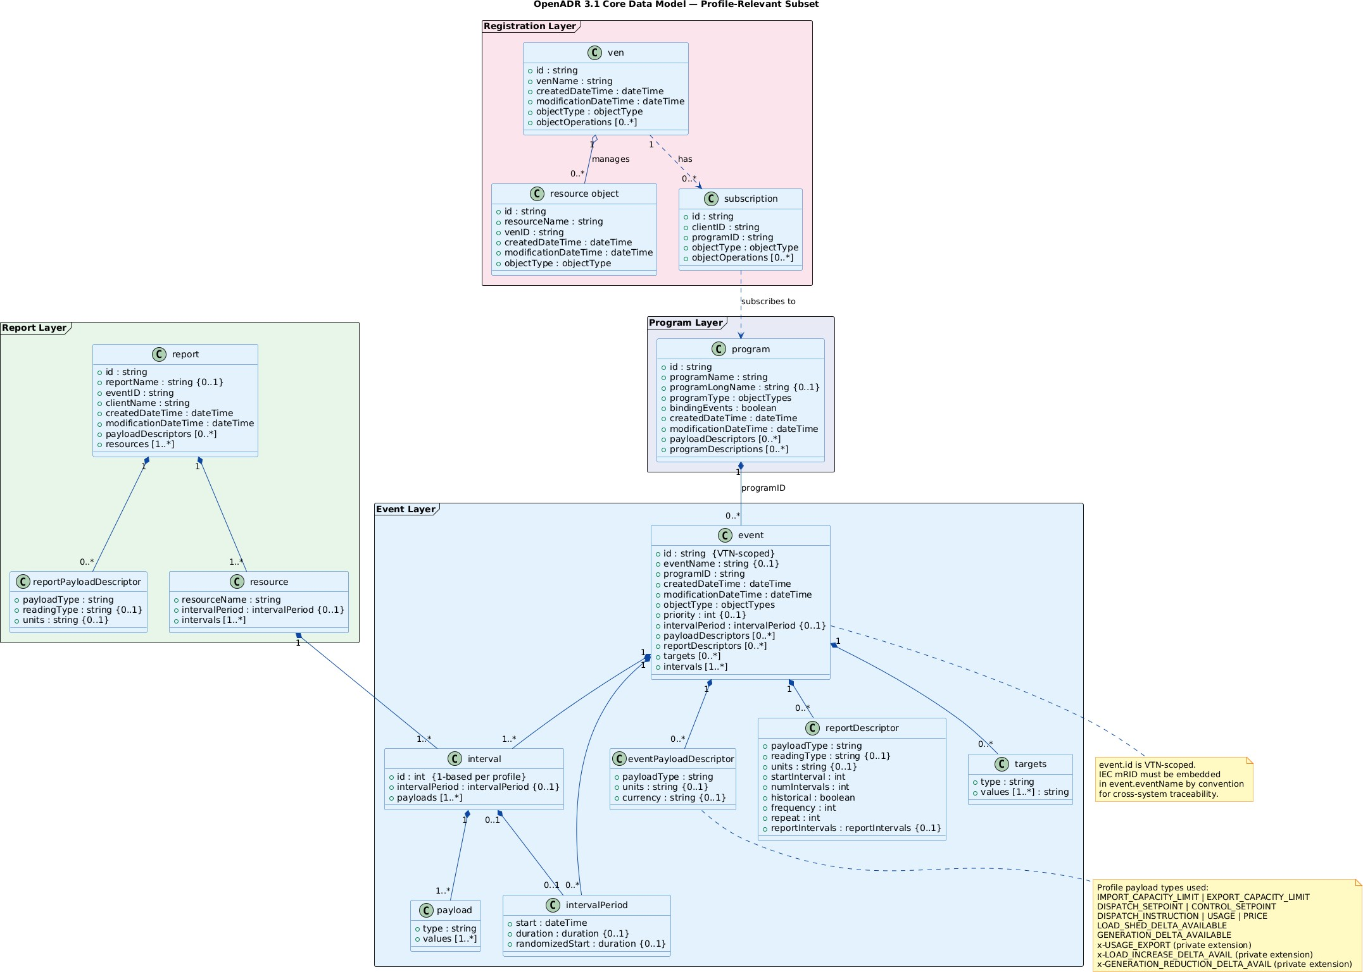

Field Mapping
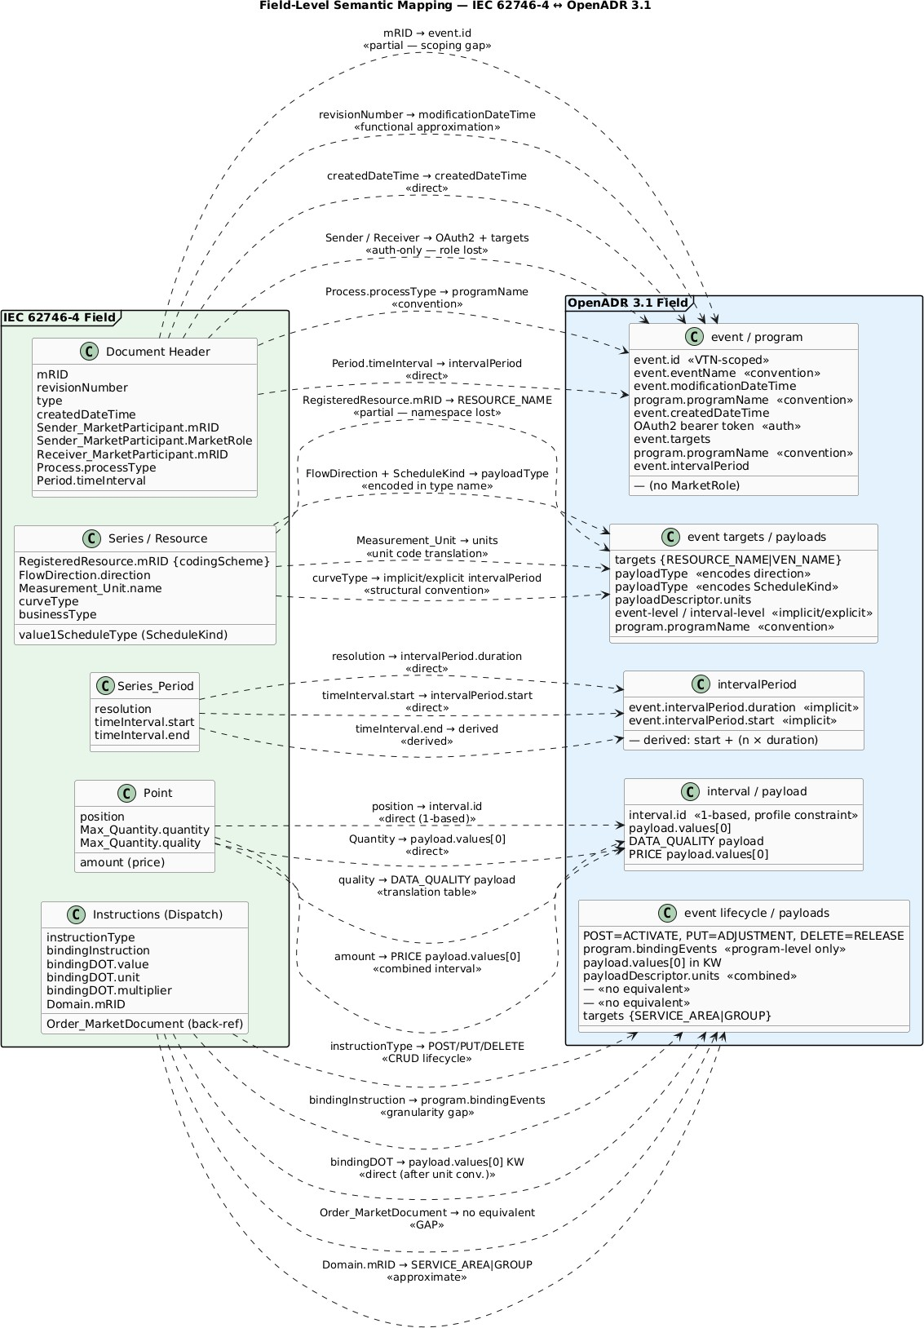

15

ScheduleKind Mapping
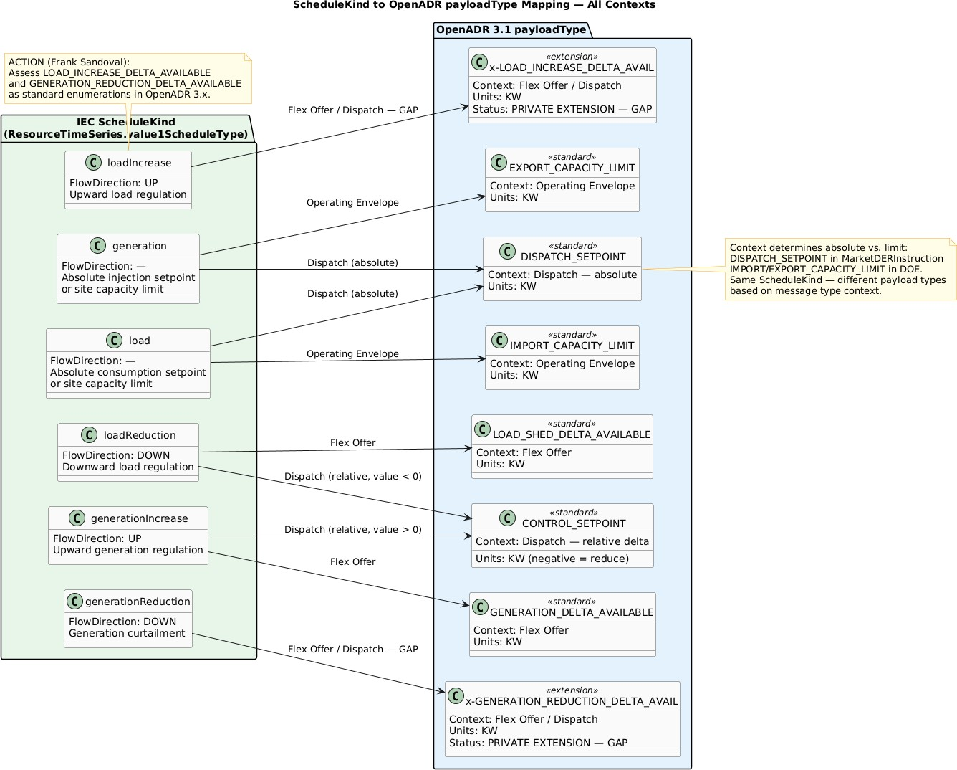

  - Standards Hierarchy
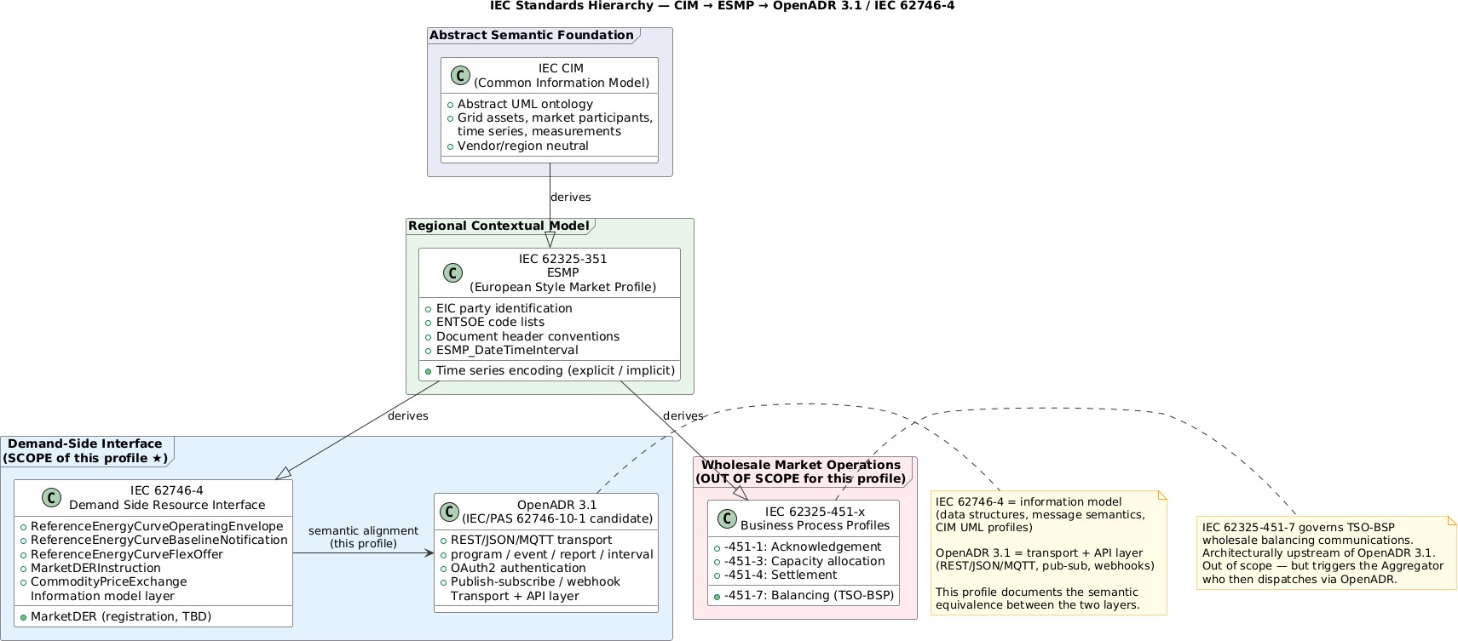

Appendix E: OpenADR 3.1 Reference Images
  - OpenADR 3.1 Data Model
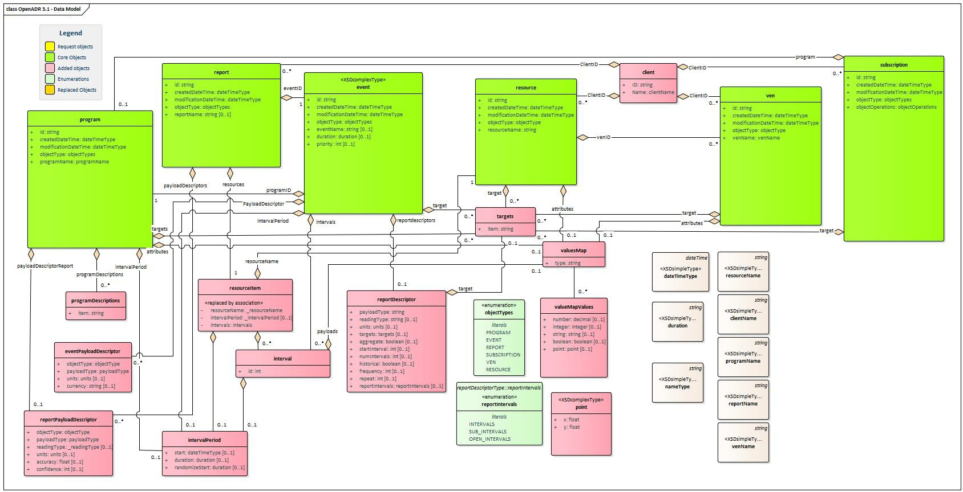

  - OpenADR 3.1 Transition Diagram


